# How To Start A Blog For Your eCommerce Website?

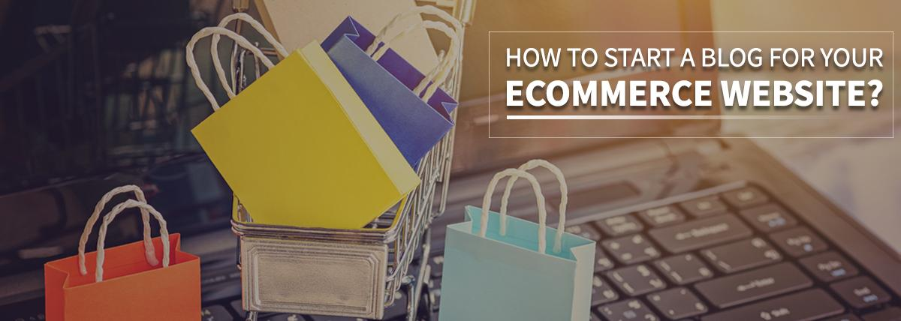

## What do you understand by eCommerce ?

E-commerce refers to selling or purchasing products or services using the internet and the payments and data transfer to execute these transactions. Therefore, it is also known as electronic commerce or internet commerce. On one side where e-business refers to all types of operations required for an online business, e-commerce specifically refers to the delivery of goods and services.

It started with the the first ever online sale-August 11, 1994 when a man sold a CD by the stand sting to his friend through his website NetMarket. Purchasing a product from a business through world wide web or e commerce was the first example of buying .

## What is the main purpose of an eCommerce website?

The main purpose of the e-commerce website is to earn profit. It is obtained by getting the attention of the user visiting the site. We can get a wide range of customers throughout the world. To attract the attention of the customer we need to create an attractive website which can be done by investing some time on doing some market research and developing a creative website. E-commerce also helps us to reach such remote customers who otherwise will not have any idea about the existence of your physical store in the market. The more you focus on your e-commerce website the more revenue as well as the profit you can earn. A proper e-commerce website can earn the reviews of the right viewers who could be your loyal customers in the future.

## Importance of Blogging

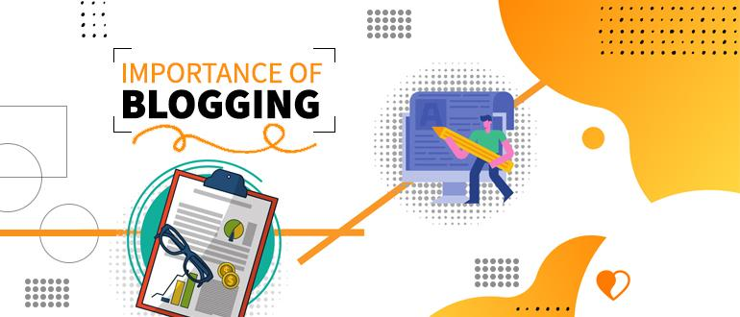

Blogging is a community based endeavour. Whether you’re an entrepreneur or blogging for marketing your venture; it helps in your business’ growth by building relationships.

1. It helps in boosting traffic on your website, who can be your future customers.

2. Blogging gives your business a voice; i.e., you can describe your business or introduce the product you’re going to launch or services you’re going to provide.

3. Keywords play the main role in blogging as it brings significant traffic to your website. If you include suitable keywords throughout the content in your blog it will help increase your web page ranking and will make it reach to more readers

Not only business is using blogging to build an audience but blogging is also starting a business to extend publishings. Blogging is one of the best solutions for business to find leads. Even [**lead generation companies**](https://www.commino.co.uk/services/lead-generation-companies/) use blogging to do marketing and to get more audience. People like to pursue blogging as the hobby and career both now. They have started making money from it. But why do people actually go into such a field? Because they want to share opinions and teach what you know. Also they develop brand and sale services.

So after knowing everything about blogs, you need to know how you can start a blog and how you can make money from it.

## These are the five ways which will help you to know how to start a blog or what are the basics of blogging:

1. Consider the different opportunities to monetize- before learning blogging you should always learn the skills of entrepreneurship so that you know how to seize every opportunity coming in your way.
2. Pick an audience to serve- whole lot of audience doesn't need your content. You have to figure out which audience you are targeting.
3. Choose a blogging platform, a domain name, and build your blog- before starting writing you have to choose a platform which suits you completely. There are many blogging platforms available and have different key features.
4. Lay the groundwork for distribution- additional research and proper word count is important for a blog. You must cover every important point related to that topic from introduction to conclusion.
5. Planning out your publishing strategy- every blog must be published on the right date and at the right time. You must also consider the needs of clients before publishing blogs and must publish it with a good eye catchy website.

## What you must include in your eCommerce website:

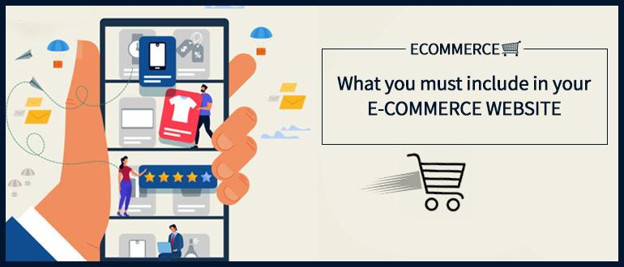

Whenever you are building an online store,the most common thing to include is a blog feature. However you part becomes super easy if the store is based on WordPress, as that’s what the platform designed for. But regardless of the things about your store and what you chose to write there are few things that you still need to include in your blog to make it attractive and customer friendly. These things include:

### An “About ” Page:

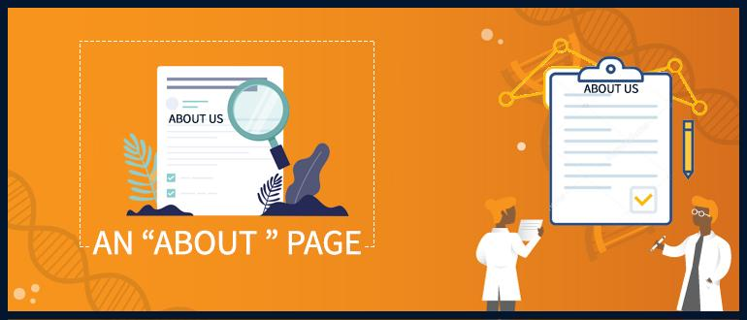

Everyone needs an identification of the person they are working with or want to work in the future. So it is very necessary to identify yourself when running a store. Customers should have a brief knowledge of you so that they can trust that you ain’t a fraud. Also providing a face and voice to your site is a good idea.

### Product Links:

Providing the link to your website in the blog itself will help the customers and save your time as well the customers ,i.e. a part of the [**CRM Strategy**](https://www.commino.co.uk/services/crm-strategy-and-planning/) Also you can provide the link of your best sellers then and there only making it easy to go overboard with the online shopping.

### Social Media Integration:



Social media integration is very important in today’s world. You need to connect with the people out there using social media. So keeping your account public or accessible to other people is helpful in these situations.

### Search engine optimization-

Search engines provide you many opportunities where you can publish your blog. One should not miss any optimization opportunity as your main goal is to develop a blog in the reader's mind. Also blogging or content helps you to add more pages to your website and people will be able to find you easily through searches or keywords.

### A call to action-



Make your blog the platform to increase potential customers by including a call to action somewhere in the blog. Customers rather than leaving a site must go and make a purchase. There are many ways by which you can increase the publishing of blogging.

An e-commerce website specifically facilitates the commercial or business transactions and the online transfer of information. These include auction sites, retail stores, business-to-business

services, financial management sites, music sites, customer-to-customer services,etc. It caters to exchange goods and services for online payment or cash-on-delivery.

## Conclusion:

Blogging means the writing, photography and other media that is self-published online. It provides an opportunity for everyone to write entries in diary-format; but now it has incorporated in websites of many business corporations. A blog is a platform where you share your thoughts; the entries can include your thoughts on a topic, quick updates or even educate others from what you have learnt. An e-commerce website specifically facilitates the commercial or business transactions and the online transfer of information. These include auction sites, retail stores, business-to-business services, financial management sites, music sites, customer-to-customer services,etc. It caters to exchange goods and services for online payment or cash-on-delivery.

**Meta Description**

If you want to start a blog for an ecommerce website then you are at the right place, Here are the tips to start a blog for your eCommerce website.

**Keywords**

Create ECommerce Website

Blog For ECommerce Website

**Author’s Bio**

**Name:** Gaurav Saraswat

**Designation:** SEO Executive

**Gravatar ID:** gaurav.technosoftwares12@gmail.com

**Social Media**: [Facebook](https://www.facebook.com/gaurav19991999) & [Linkedin](https://www.linkedin.com/in/gaurav-saraswat-3a0286169) & [Twitter](https://twitter.com/Gaurav41478131?s=09)



Myself Gaurav Saraswat and I serve as a Seo executive at one of the best [**Email Marketing Companies**](https://www.commino.co.uk/services/email-marketing-companies/) Techno Softwares. I’m a content writer as well. Feel free to ask anything related to SEO and Content Writing.